**MATHEMATICS** **TEST 6 – Logarithms & Confidence Intervals**

Mark: ____ / 69

__________%

**Methods Unit 4**

**SECTION ONE (Calculator Free)**

**Time: 30 mins Total: ______/ 35 marks**

**Name: ……………………………………… Date: ………………….**

Question 1 (8 marks)

Express each of the following as a single logarithm:

1. i)  (1 mark)
2.  (2 marks)

iii)  (3 marks)

(b) Evaluate the following showing full working:

 (2 marks)

Question 2 (10 marks)

Solve each of the following equations, showing all working.

1.  (1 mark)
2.  (3 marks)
3.  (3 marks)
4.  (3 marks)

Question 3 (7 marks)

(a) Differentiate  (1 mark)

(b) Determine  (3 marks)

(c) Determine each of the following anti-derivatives, simplifying your answer where possible:

i)  (1 mark)

ii)  (2 marks)

Question 4 (3 marks)

Calculate the following definite integral, simplifying your answers using logarithmic laws.



Question 5 (8 marks)

(a) Sketch the graph of $y=\log_{4}{(x+2)}-1$ on the axes below, clearly showing the location of all asymptotes and axes intercepts. (3 marks)

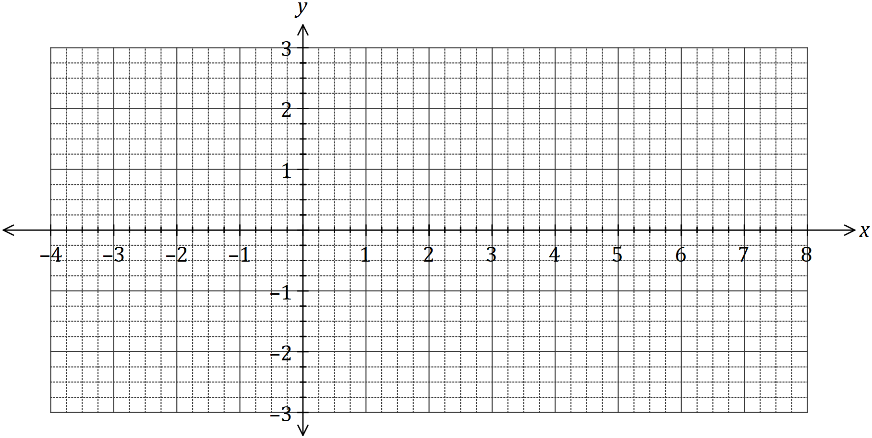

(b) Determine the coordinates of the $y$-intercept of the graph of $y=4-\log_{5}{(x+0.2)}$.

(2 marks)

(c) The graph of $y=\log_{a}{(x-a)}$, where $a>1$, passes through $(12, 2)$. Determine the coordinates of the root of the graph. (3 marks)

**MATHEMATICS**

**Methods Unit 4**

**TEST 6 – Logarithms & Confidence Intervals**

**SECTION TWO (Calculator Allowed)**

**Time: 30 mins Total: ______/ 34 marks**

**Name: ……………………………………… Date: ………………….**

Question 1 (7 marks)

Reigning Cats & Dogs (RC&D) is a major pet supply company. The advertising executive for RC&D is interested in calculating the proportion of customers that do most of the pet supply shopping in RC&D stores.

The advertising executive conducted an email survey of 375 randomly chosen people and found that 72 did most of their pet supply shopping at RC&D.

(a) i) Calculate the sample proportion of people who did most of their pet supply shopping at RC&D. (1 mark)

ii) Determine the 99% confidence interval for the proportion of people who did most of their pet supply shopping at RC&D. Give your answer to 4 decimal places. (2 marks)

iii) What is the margin of error of the 99% confidence interval? Give your answer to 4 decimal places. (1 mark)

iv) Suggest a different confidence level (as a percentage) for a confidence interval that would **reduce** the margin of error compared to part (iii). (1 mark)

Market research in this industry suggests that the actual proportion of people who do most of their pet supply shopping at RC&D is 0.13.

(b) Does this result suggest the advertising executive has made errors in the sampling process? Your answer should make reference to your answer from a(ii). (2 marks)

Question 2 (7 marks)

The proportion of boats in Western Australia being powered by oversized motors is *p*.

(a) The WA Water Police wants to determine *p* within 6% with 95% confidence. How many boats should be examined at a random check? (3 marks)

**(b)** Over a one-month period, the WA Water Police carry out random checks of boats. A 95% confidence interval calculated for the proportion of boats with oversized motors is (0.412, 0.508). Determine the number of boats in the sample that have an oversized motor.

(4 marks)

Question 3 (7 marks)

(a) What is the minimum sample size required to estimate a population proportion to within 0.02 with 90% confidence? (3 marks)

(b) Describe the effect of each of these factors on the **width** of a confidence interval;

i) Sample size (1 mark)

ii) Confidence level (1 mark)

iii) Sample proportion (2 marks)

Question 4 (6 marks)

The instantaneous rate of change of the number of fish over *t* weeks, being farmed in a fish farm can be modelled by  where  is the population after *t* weeks.

(a) If after 5 weeks there are 12 000 fish left, determine an expression for . (3 marks)

(b) i) Calculate the initial number of fish when the study began. (1 mark)

1. When the decline in fish each week falls below 500, the farmer is no longer as concerned for his fish stock. During which week does this occur? (2 marks)

Question 5 (7 marks)

The ear has the remarkable ability to handle an enormous range of sound levels. In order to express levels of sound meaningfully in numbers that are more manageable, a logarithmic scale is used, rather than a linear scale. This scale is the decibel (dB) scale.

The sound intensity level, *L*, is given by the formula below:

 dB where *I* is the sound intensity and *I­0* is the reference sound intensity.

*I* and *I­0* are measured in watt/m2 .

1. Listening to a sound intensity of 5 billion times that of the reference intensity (I = 5 × 10­­9 *I­0*) for more than 30 minutes is considered unsafe. To what sound intensity level does this correspond? (2 marks)
2. The reference sound intensity, *I­0* , has a sound intensity level of 0 dB. If a household vacuum cleaner has a sound intensity I = 1 × 10–5 watt/m2 and this corresponds to a sound intensity level L = 70 dB, determine *I­0* . (2 marks)

The average sound intensity level for rainfall is 50 dB and for heavy traffic 85 dB.

(c) How many times more intense is the sound of traffic than that of rainfall? (3 marks)